Campaign Manager_BMG_GUI_Manual

Principal Entity
PE ID value is mandatory while executing the campaign through portal .For insertion of PE ID user has to go to Manage Principal Entity TAB and fill the DLT approved PE ID value along-with description of Entity name etc . Once the PE ID is filled same will be whitelisted for future campaign as well.

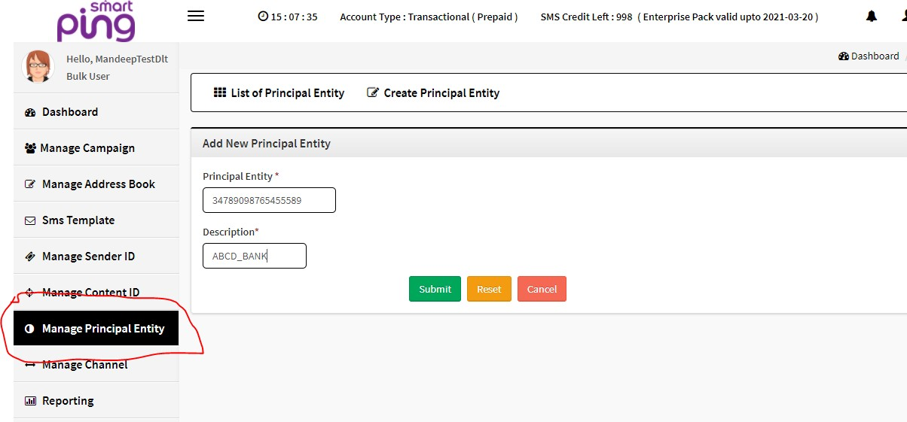

List of added PE IDs by user

User can check the list of PE IDs whitelisted under the particular account.

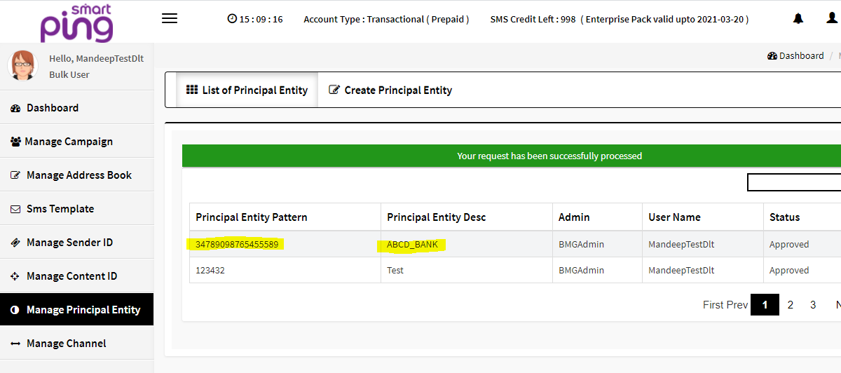

Manage Campaign
While scheduling the campaign , selection of desirable PE ID would be required from the whitelisted PE IDs which will be visible under the drop down selection.
Presently for Template ID, user may select option as “default” available under the Content ID TAB .

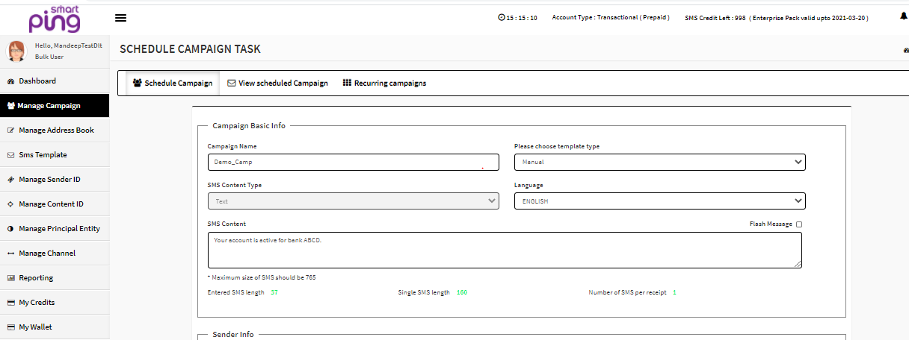

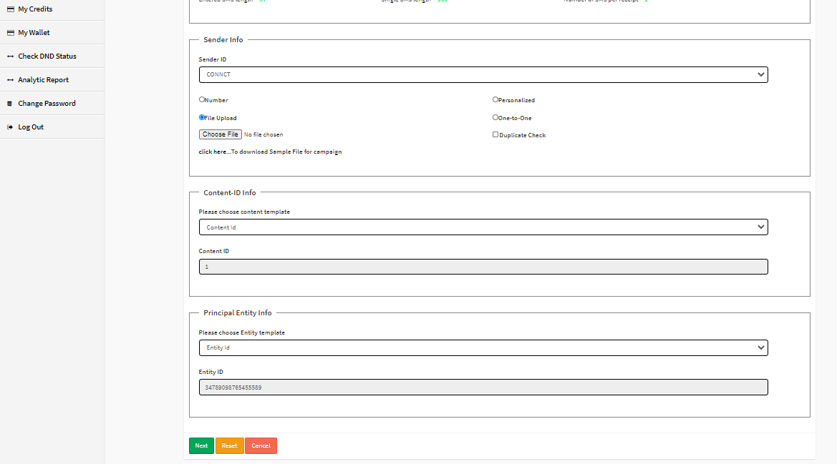

VIEW REPORTING

User may select below options in reporting section for download the all kind of reports.

